YOUR 24-hour Radio Reading Service!
Iowa Radio Reading Information Service
For the Blind and Print Handicapped, Inc.

IRIS Newsletter Fall 2012 – Volume 20, Issue 3

A message from Mary Ann Nielsen, chair of the IRIS Board of Directors:
Thanksgiving is a very special time of the year when we pause to reflect on the many blessings in our lives. My three grandsons (7 and 4-year old twins) definitely top my list! For you, it may be your family, your health, your job, or other special blessings that come to mind. And for thousands of Iowans who cannot easily see or hold the printed word, the Voices of IRIS volunteers are high on their list of blessings.
2012 has been an exciting year for IRIS! Thanks to the generosity of an IRIS volunteer reader and her husband, Audio Description services were recently introduced. During designated Broadway performances, trained IRIS volunteers describe the action taking place on stage over special headsets to visually-impaired patrons. Just imagine how exciting it is for individuals to experience Broadway performances in this way -- I personally get goose bumps just thinking about it!
Additionally, IRIS established The IRIS Legacy Society so that listeners, readers, and supporters can remember IRIS in their final planning. Fittingly, IRIS received its first legacy gift from Roger Larson's estate. Roger, an avid listener from Eagle Grove, felt connected to the world around him each time he turned on his IRIS radio. His legacy gift is an enduring investment in the future of IRIS.

So why am I writing to ask you for financial support? It's because the operating funds in our treasury are low, and the IRIS Board is dedicated to keeping the Voices of IRIS on the air. To do this, we need your financial help and support -- whether it's a gift of $1 or $1,000. IRIS is so proud that we’ve been able to serve our listeners at no cost to them since day one. IRIS works to keep expenses as low as possible without diminishing services; however, please recognize that running a program such as ours costs money and expenses increase annually.
IRIS exists because of the financial support from listeners, corporations, foundations, volunteers and other supporters. Your financial gift before the end of 2012 will truly help sustain IRIS services for thousands of listeners - and you will have another blessing to add to your list. Together, we can get through this time of financial crisis, and we are truly thankful for you!
Thanksgiving is a very special time of the year when we pause to reflect on the many blessings in our lives. My three grandsons (7 and 4-year old twins) definitely top my list! For you, it may be your family, your health, your job, or other special blessings that come to mind. And for thousands of Iowans who cannot easily see or hold the printed word, the Voices of IRIS volunteers are high on their list of blessings.

2012 has been an exciting year for IRIS! Thanks to the generosity of an IRIS volunteer reader and her husband, Audio Description services were recently introduced. During designated Broadway performances, trained IRIS volunteers describe the action taking place on stage over special headsets to visually-impaired patrons. Just imagine how exciting it is for individuals to experience Broadway performances in this way -- I personally get goose bumps just thinking about it!
Additionally, IRIS established The IRIS Legacy Society so that listeners, readers, and supporters can remember IRIS in their final planning. Fittingly, IRIS received its first legacy gift from Roger Larson's estate. Roger, an avid listener from Eagle Grove, felt connected to the world around him each time he turned on his IRIS radio. His legacy gift is an enduring investment in the future of IRIS.

So why am I writing to ask you for financial support? It's because the operating funds in our treasury are low, and the IRIS Board is dedicated to keeping the Voices of IRIS on the air. To do this, we need your financial help and support -- whether it's a gift of $1 or $1,000. IRIS is so proud that we’ve been able to serve our listeners at no cost to them since day one. IRIS works to keep expenses as low as possible without diminishing services; however, please recognize that running a program such as ours costs money and expenses increase annually.
IRIS exists because of the financial support from listeners, corporations, foundations, volunteers and other supporters. Your financial gift before the end of 2012 will truly help sustain IRIS services for thousands of listeners - and you will have another blessing to add to your list. Together, we can get through this time of financial crisis, and we are truly thankful for you!

Additionally, IRIS established The IRIS Legacy Society so that listeners, readers, and supporters can remember IRIS in their final planning. IRIS recently received its first legacy gift from Roger Larson's estate. Roger, an avid listener from Eagle Grove, felt connected to the world around him each time he turned on his IRIS radio. His legacy gift is an enduring investment in the future of IRIS.

So why am I writing to ask you for financial support? It's because the operating funds in our treasury are low, and the IRIS Board is dedicated to keeping the Voices of IRIS on the air. To do this, we need your financial help and support -- whether it's a gift of $1 or $1,000. IRIS is so proud that we’ve been able to serve our listeners at no cost to them since day one. IRIS works to keep expenses as low as possible without diminishing services; however, please recognize that running a program such as ours costs money and expenses increase annually.
IRIS exists because of the financial support from listeners, corporations, foundations, volunteers and other supporters. Your financial gift before the end of 2012 will truly help sustain IRIS services for thousands of listeners - and you will have another blessing to add to your list. Together, we can get through this time of financial crisis, and we are truly thankful for you!

So why am I writing to ask you for financial support? It's because the operating funds in our treasury are low, and the IRIS Board is dedicated to keeping the Voices of IRIS on the air. To do this, we need your financial help and support -- whether it's a gift of $1 or $1,000. IRIS is so proud that we’ve been able to serve our listeners at no cost to them since day one. IRIS works to keep expenses as low as possible without diminishing services; however, please recognize that running a program such as ours costs money and expenses increase annually.
IRIS exists because of the financial support from listeners, corporations, foundations, volunteers and other supporters. Your financial gift before the end of 2012 will truly help sustain IRIS services for thousands of listeners - and you will have another blessing to add to your list. Together, we can get through this time of financial crisis, and we are truly thankful for you!

IRIS exists because of the financial support from listeners, corporations, foundations, volunteers and other supporters. Your financial gift before the end of 2012 will truly help sustain IRIS services for thousands of listeners - and you will have another blessing to add to your list. Together, we can get through this time of financial crisis, and we are truly thankful for you!

LISTENER SPOTLIGHT: Gloria Alverson
Gloria has been listening to IRIS since we started broadcasting in 1989. Her original IRIS radio just gave out after 23 years! Gloria was born with glaucoma in 1932 and lost her vision completely by the age of 25. A 1952 graduate of the Iowa Braille and Sight Saving School, Gloria has been a dedicated volunteer for the Iowa Department for the Blind and the Veterans Administration. These days, Gloria enjoys water exercise and reading mysteries. Her favorite IRIS features are the obituaries and Midweek Shopping Cart. She says she is thankful for the Voices of IRIS each day. “IRIS makes me feel that I can do a few things on my own.”

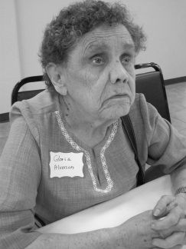
2012 IRIS Ice Cream Social: Iowa Public Radio Receives Kirsner Award
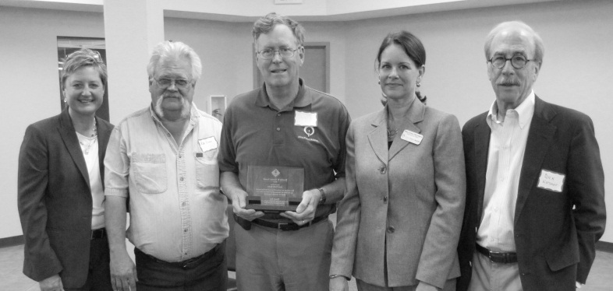
Friends from Iowa Public Radio received the 2012 Dorothy B. Kirsner award recognizing their significant and lasting impact on the lives of Iowans who are blind or visually impaired. IPR not only carries our signal – they CARE for our listeners and are as dedicated to the IRIS signal as they are to their own. Along with Iowa Department for the Blind Director Richard Sorey and Dorothy’s son, Dick Kirsner, it was a pleasure to present this award to two men who have been watching over our signal for more than twenty years, IPR engineers Dave Knippel and Dick Owens. (Pictured above: Maryfrances, Dick Owens, Dave Knippel, IPR CEO Mary Grace Herrington and Dick Kirsner)

Lots of Smiles from the Ice Cream Social. More photos at iowaradioreading.org
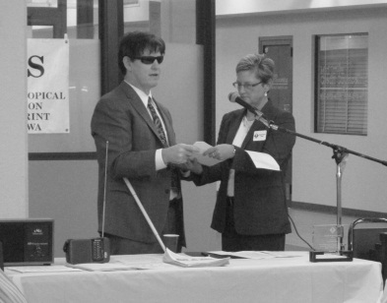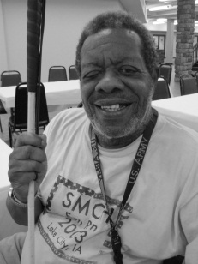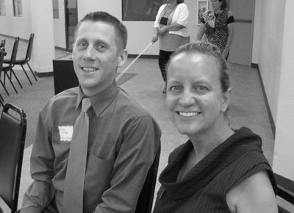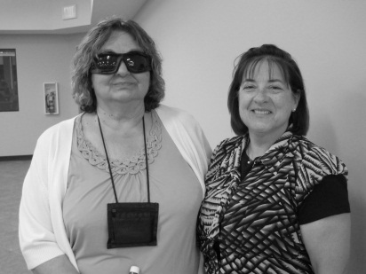

IRIS By the Numbers:
Programming: 24 Hours per day – Every day of the year
Coverage: Over 3,000 listeners statewide in hospitals, private homes and facilities
Volunteers: More than 400 volunteers reading from 7 IRIS locations
Access: Custom receivers, web stream, podcasts, mobile phones & mobile devices
Equipment Costs to IRIS: From $33 to $335 per listener depending on location
Programming Cost to IRIS: 13¢ per listener per day
Equipment Cost to Listeners: $0 - - Programming Cost to Listeners: $0

“Thank you for the good service. I hear you every morning!”
Roger H. Larson (July 9, 1929 – June 19, 2012)
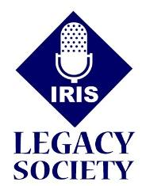
The history of IRIS would not be complete without Roger Larson. Roger spent his life tuning pianos – coaxing beautiful sounds from each instrument with tender precision. His personality was music to us all. From the day we installed his first IRIS radio in 1989, Roger became our “field staff” in the Fort Dodge area. He monitored our signal and called whenever there was a problem or he just wanted to chat about the news. Ten years ago, he asked about including IRIS in his estate planning. We helped him through the simple process. In recent years, his phone calls always ended with an excited reminder that he would be leaving IRIS a gift someday. Roger passed away in June. While we miss his special phone calls, we are grateful to have enjoyed such a wonderful friend for so many years.
True to his word, IRIS received a gift from Roger’s estate. To recognize Roger and everyone who includes IRIS in their estate planning, we’ve established the IRIS Legacy Society. Roger is our first member!
If you would like to become a member as well, simply call our office to get started. There is no minimum required and it is not necessary that you share your specific intentions with IRIS. If you have already made a planned gift to IRIS, please call so that we can make sure your gift is properly documented.
Out & About: Vision Loss Resource Fairs in Iowa City and Waterloo
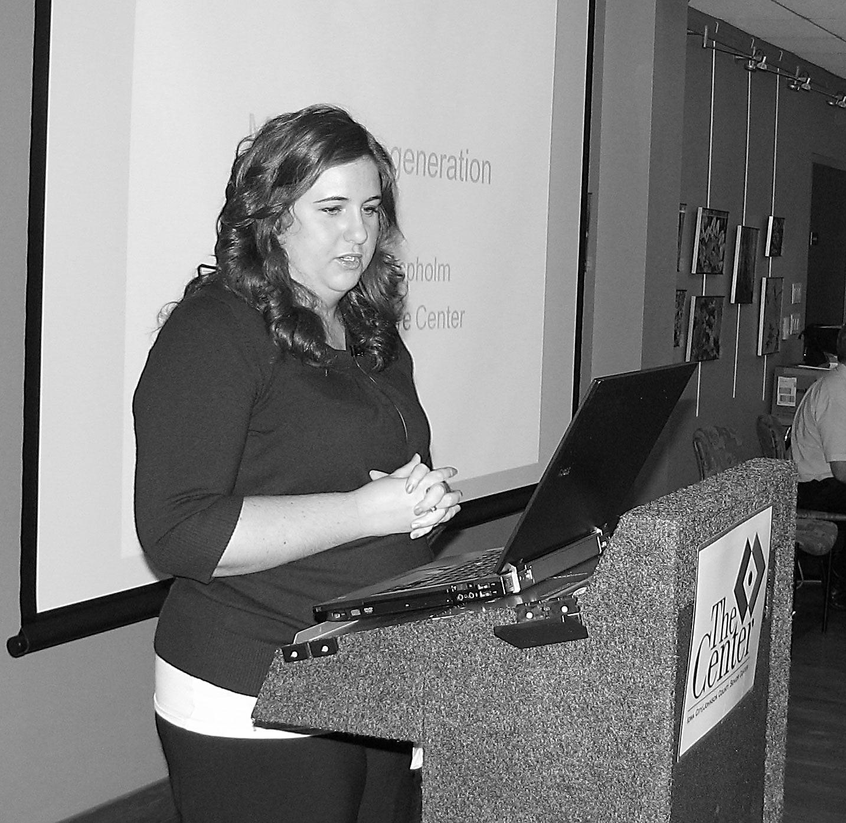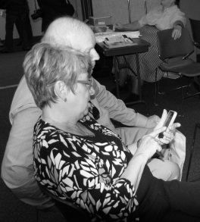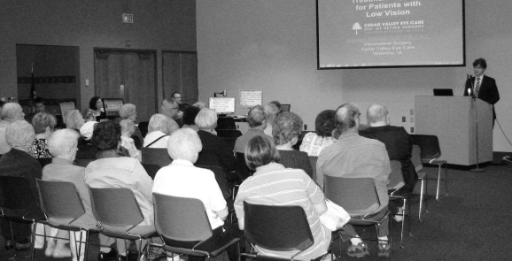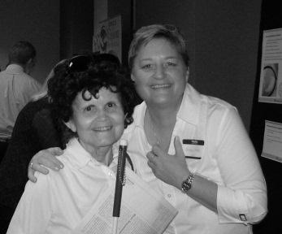

Ia. Dept. for the Blind Director Richard Sorey speaks to folks at the Vision Loss Resource Fair in Waterloo.
Cedar Falls listener Rebecca Barrionuevo visits the IRIS booth
at the Waterloo fair.
Dr. Aspholm updates macular degeneration at the Iowa City fair.
New Iowa City listeners hear IRIS on their mobile phone.

Notes from IRIS Listeners:
“Thank your readers! I appreciate it so much, especially during the night.” Rosalyn
“I am so grateful for your service. My daughter and granddaughter both read The Des Moines Register. I do so enjoy it because I always read so much.” Marilyn
“I appreciate the work you do! Thank you very much.” Janice
“I enjoy the obituaries and opinions. Thank you.” Rosemary
“Tremendous! IRIS brings the outside world in.” Dorothy
The IRIS Newsletter is published quarterly by the Iowa Radio Reading Information Service for the Blind and Print Handicapped, Inc., 100 E. Euclid Ave., Suite 117, Des Moines, IA 50313

Take IRIS Wherever You Go!
Thanks to support from the Iowa Department for the Blind, you can access IRIS on any smart phone (iPhone or Android) or mobile device (iPad or Android tablet). Download the free iBlink Radio app from Serotek and set IRIS as a favorite!

IRIS One of 10 FootPRINT Fund Award Winners!
This newsletter was made possible by a $1,000 award from the Allegra FootPRINT fund. The FootPRINT fund awards $10,000 annually in marketing and printing services to 10 select nonprofit organizations in the community. Thank you, Allegra, for choosing IRIS in 2012!

Turning the Corner:
IRIS remains an independent non-profit organization. We are so thankful for contributions we received from April through September:

Individuals:

Joy Adolphson-Harvey
Ervin & Norma Albertson
Helen Barth
Terrie & Dale Baze
Joseph Behrendt
Arlis Black
Louis Blair
Helen & Karen Blunt
Eileen & Ron Bowerman
David & Susan Brown
Mary Jo Bruett
Dick Cayet
Rodney & Janet Constable
Rebecca Cox
Robert Davis
Eleanor Day
Elaine & Denton Ericson Ramona Esbeck
James & Betty Feld
Marilynn Gillingham
Steve & Willona Goers
Julie & Clifford Gold
John & Irene Graether
Irene, Delores & Mary Hair
Teresa Hicks
Dorothy Hockenberg
Julie James
Tom & Karla Kelly
Richard Kirsner
Ruth Kleinow
Jody Kolmen
Roger Larson
Lorraine Lester
Kelly Mahanna
Mary Ann Martin
Dixie McClelland
Harriette Milburn
Eleanor Perry Trust
Richard & Linda Pint
Archie & Virginia Rohden
David & Jeanette Saurman LaDonna & Robert Seliger
James & Susan Severino
Carol Sharp
Marvin & Rosalyn Smith
Scott Splavec
John Thompson
Sally Vander Linden
Bonnie & Michael Whitson
L.J. & Catherine Witte
Troy & Amy Womack

Organizations:

American Legion Foundation of Iowa
Delta Gamma Foundation
Hampton Lions Club
Hy-Vee Foundation
Mason City Evening Lions Club
Pella Lions Club
Pleasant Hill Lions Club
Polk County Bd. of Supervisors
Principal Financial Group Foundation
Windsor Heights Lions Club

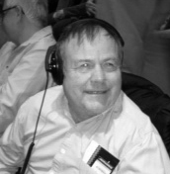
A Sensational Start!
Larry Wilken has lived in Des Moines for more than 30 years. On
an October Sunday, he took a bus downtown and walked into the Civic Center for the very first time. He had purchased a ticket to see Les Miserables. Larry picked up his IRIS headset and was shown to his seat. He settled in and donned his headset to hear information about the sets, costumes and storyline. With the first note of the overture, Larry Wilken made history. Larry was the first person to experience live Audio Description in Central Iowa. In another part of the theater, IRIS Sensation volunteers Dorothy Hockenberg and Bobby Bailey followed the show on a monitor and described every bit of the action to Larry on his headset. It was an absolutely amazing experience for us all.
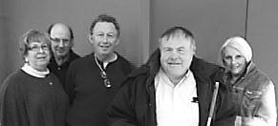
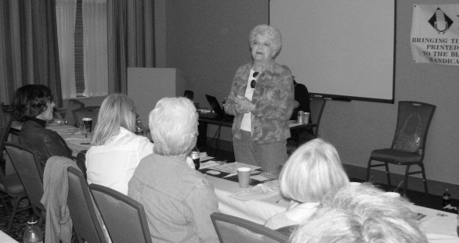
In June, IRIS decided to explore Audio Description Services, knowing we would need to raise money for equipment and training. In a heartbeat, longtime IRIS volunteer Eileen Bowerman and her husband Ron stepped forward with a $10,000 check to begin the program! We named our team Sensation. The incredible staff at the Civic Center embraced our project, installed the equipment and agreed to launch this new service with us immediately. In September, 25 IRIS Sensation volunteers spent 3 days learning the art of Description and chose Dorothy and Bobby as our first team for Les Miserables. The Civic Center provided scripts and tickets for Bobby and Dorothy to study the show. By the time Larry put on his headset on October 7th, we were ready. So what did Larry think? “This was the first time I’ve experienced anything like this. It was great to be there in person.” he said. “Bobby and Dorothy did a great job. They even described the funny actions so that I could laugh along with everyone else.”
Today, IRIS Sensation description is available at the Sunday matinee performances of the Willis Broadway Series at the Civic Center. Upcoming dates include War Horse December 16 and The Book of Mormon January 27 and February 3.
Additional described performances will be added at other theaters, events and cities in the coming months. Learn more about IRIS Sensation Audio Description Services at iowaradioreading.org. As with all our services, audio description is provided at no cost to IRIS listeners.
What is this Thing?
This is called a QR code. You can download a free QR code reader on any smart phone or mobile device. This particular code takes you right to the front page of the IRIS website. Give it a try!
Iowa Radio Reading Information Service for the Blind and Print Handicapped, Inc.
100 East Euclid Avenue – Suite 117
Des Moines, IA 50313-4582
Iris89@netins.net

Return Service Requested

IRIS Delivers Equal ACCESS to Information
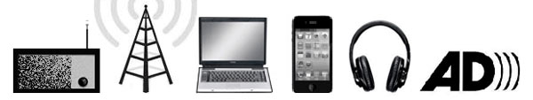
Receivers DTV Streaming Mobile Podcasts Description

iowaradioreading.org 515-243-6833 1-877-404-4747

Board of Directors:

Mary Ann Nielsen, Chair
Patrick McNulty, Vice-Chair
See Rodari, Treasurer
Catherine Witte, Secretary
Chip Albright
Diane Boatwright
Mollie Cooney
Becky Cox
Dennis Crabtree
Rob Davis
Dr. Jim Feld
Julie Gold
Susan Kimelman
Laura McVay
Joe Meisner
Ron Rosenblatt
Bonnie Whitson
Jerry Wickersham
Staff:
Maryfrances Evans
Jim Boyd
Caitlyn Snitker

