Iowa Radio Reading Information Service
For the Blind and Print Handicapped, Inc.

IRIS – YOUR 24-hour Radio Reading Service!
IRIS Newsletter – June 2012

Ice Cream Social moves to IRIS Headquarters in August
Join us Thursday, August 23rd from 4 to 6pm for our Annual Ice Cream Social. This year, the event will take place at our headquarters on the lower level of the Park Fair Mall. It’s a lovely opportunity to meet listeners, readers and staff while we enjoy some sweet treats! Don’t let a lack of transportation keep you away – we will be happy to pick you up and take you home. Please let us know if you are planning to attend 515-243-6833.

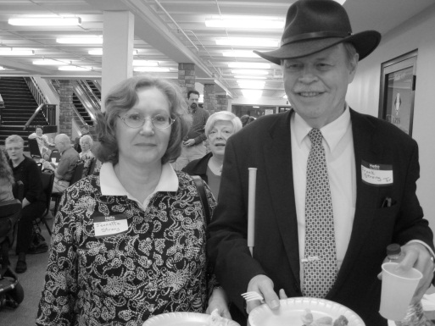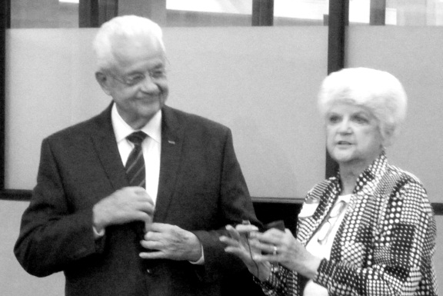
Celebrate IRIS a BIG Success!
A big “thank you” to everyone who attended our Celebrate IRIS event in March. It was a great evening with food, fun and friends. We were thrilled that Congressmen Latham and Boswell were able to stop by to visit with our listeners. A special thanks to the folks at Texas Roadhouse for providing outstanding barbeque sandwiches! Pictured: Jeanette and Frank Strong are all smiles, Tom Latham welcomes our listeners, Leonard Boswell and IRIS Board Chair Mary Ann Nielsen share the microphone. (More photos at www.iowaradioreading.org)

Come Celebrate IRIS in YOUR Area!
We are finalizing dates for Celebrate IRIS gatherings throughout the state.
These are casual get-togethers for listeners, readers and friends. When a date is set for your area, we will contact you by phone to let you know. Transportation can be arranged for you.

Reader Spotlight: Dorothy Hockenburg
Kirsten was diagnosed with macular degeneration three years ago and has
The VOICES of IRIS: Dorothy Hockenberg
Dorothy’s voice has been an IRIS staple for more than 12 years. A retired retail shop owner, Dorothy feels her work at IRIS is “people-based”, much like running her own store. “The staff and volunteers are like-minded and fun to be with. I really enjoy it. I plan to keep reading as long as you’ll have me!”

IRIS Welcomes Four New Members to Our Board of Directors
Dr. Jim Feld is a retired dentist and an IRIS listener. Jerry Wickersham is a long-time IRIS reader with a love for all things theater. Joe Meisner is a massage therapist from Urbandale and a new IRIS listener. Laura McVay joins the board after years of reading for IRIS and keeping an eye on our accounting for us. Welcome to all new directors and thank you for your dedication to IRIS.

We Get By with a Little Help From Our Friends!
IRIS remains an independent non-profit organization – and we are so proud to continue to provide our services and equipment at no cost to our listeners. In order to sustain our mission, we must constantly seek the financial support needed to keep the voices of IRIS on the air for you. Our thanks to the fantastic folks who have contributed to IRIS through March of this year:

Individuals:

A Engman
A. Schuessler
J. Dixson
P. Greenfield
R. Jones
C. Strief
R. Fanter
R. Clayton
C.L. Andresen
P. Thoms
M. Buechler
L. Rosenblatt
B. Meisenheimer
E. Sainer
L. Koster
C. Lewis
R.L. Nelson
L. Blair
M. Dorcey
H. Blunt
D. Crabtree
D. Moore
S. Splavec
B. Legler
D. Brown
R. Constable
C. Sharp
S. Goers
R. Nesler
J. Armstrong
K. Lundgren
M. McVeety
T. Gruis
L Seleger
I. Hair
D. Saurman
N. Nichols
R. Albright
L.J. Witte
B. Whitson
J. Davis
E. Perry

Organizations:

Iowa West Foundation
Principal Financial Group Foundation
Prairie Meadows Racetrack and Casino
Armchair Travelers
Hampton Lions Club
Windsor Heights Lions Club

Our Current Program Schedule –

MONDAY
Midnight – American Past
1am – Commentary
6am – Cover to Cover
7am – Wall Street Journal
8am – Local Papers/Disability Topics
9am – Des Moines Register
Noon – Pet Hour
1pm – Old Friends
2pm – New York Times
3pm – World Safari
4pm – Iowa Salute
5pm – Ames Tribune/CB Nonpareil
6pm – Des Moines Register
9pm – Business Record
10pm – Cityview
11pm – Ames Tribune
TUESDAY
Midnight – Business Commentary
1am – Business Week
2am – World Safari
3am – Money Matters
4am – Diabetes News
5am – NY Times Book Reviews
6am – People’s Pharmacy
7am – Wall Street Journal
8am – Local Papers/Diabetes News
9am – Des Moines Register
Noon – People
1pm – In the Kitchen
2pm – New York Times
3pm – National Geographic
4pm – Access Iowa
5pm – Ames Tribune/CB Nonpareil
6pm – Des Moines Register
9pm – Magazine Picks
10pm – Readers Digest
11pm – Ames Tribune
WEDNESDAY
Midnight – Blind Handyman
1am – Rolling Stone
2am – Sports Illustrated
3am – Old Friends
4am – New Yorker
5am – Mother Earth
6am – In Focus
7am – Wall Street Journal
8am – Local Papers/In the Kitchen
9am – DM Register
Noon – Midweek Shopping Cart
1pm – At Home
2pm – New York Times
3pm – Oprah
3:30pm – Catalogs
4pm – Cityview
5pm – Ames Tribune/CB Nonpareil
6pm – Des Moines Register
9pm – Midweek Shopping Cart
10pm – Mother Earth
11pm – Ames Tribune
THURSDAY
Midnight – Old Friends
1am – Good Old Days
2am – It Makes a Difference
3am – Disability Topics
4am – Money Matters
5am – National Enquirer
6am – People’s Pharmacy
7am – Wall Street Journal
8am – Local Papers/Personal World
9am – Des Moines Register
Noon – Consumer Advocate
1pm – Time Magazine
2pm – New York Times
3pm – Smithsonian
4pm – Midweek Shopping Cart
5pm – Ames Tribune/CB Nonpareil

(THURSDAY CONTINUED)
6pm – Des Moines Register
9pm – Midweek Shopping Cart
10pm – Mother Earth
11pm – Ames Tribune
FRIDAY
Midnight – Multicultural Press
1am – People
2am – Apple a Day
3am – To Your Health
4am – Time
5am – Money Matters
6am – Business Record
7am – Wall Street Journal
8am – Local Papers/Personal World
9am – Des Moines Register
Noon – Readers Digest
1pm – To Your Health
2pm – New York Times
3pm – Pet Hour
4pm – Cover to Cover
5pm – Ames Tribune/CB Nonpareil
6pm – Des Moines Register
9pm – Sports Illustrated
10pm – Newsweek
11pm – Ames Tribune
SATURDAY
Midnight – Apple a Day
1am – Time
2am – Nothing but the Truth
3am – New Yorker
4am – Newsweek
5am – Consumer Advocate
6am – Oprah
6:30am - Catalogs
7am – Science Hour
8am – Iowa Salute
9am – Des Moines Register
Noon – Multicultural Press
1pm – Your Personal World
2pm – Money Matters
3pm – Apple a Day
4pm – In Focus
5pm – Ames Tribune
6pm – Des Moines Register
9pm – Blind Handyman
10pm – Nothing but the Truth
11pm – American Past
SUNDAY
Midnight – Cover to Cover
1am – Wall Street Journal
2am – Smithsonian
3am – Business Commentary
4am – Multicultural Press
5am – Inner Life
6am – Time
7am – Polk County Senior
7:30am – AARP Report
8am – Local Papers/Business Week
9am – Des Moines Register
1pm – Magazine Picks
2pm – Bookcase
3pm – Art Fare
4pm – Polk County Senior
4:30pm – AARP Report
5pm – DM Register
9pm – It Makes a Difference
10pm – People’s Pharmacy
11pm – Cityview

Hear our schedule each day at 7:58am. Schedules can be sent to you in braille, large print or audio formats. Just call 1-800-404-4747.

Vision Expo 2012
The Iowa Department for the Blind‘s Vision Expo will be held on Wednesday, August 1 from 12:00 to 4:30pm at the Hope Reformed Church in Spencer, Iowa. Vendors will be on hand to demonstrate their products and services.
Take Me Out to the Beep Ball World Series!
The Beep Baseball World Series is coming to Ames – July 22 through July 28!
“Beep Ball” is an adaptive version of America’s favorite pastime for the blind and visually impaired. The Iowa Lions/Iowa Lions Foundation hit a grand slam in bringing the World Series to Iowa this year. Proceeds will benefit the Lions Clubs of Iowa’s services, especially those related to sight preservation and blindness prevention. Our Lion, Lioness and Leo friends have supported IRIS for so many years. This is a chance for us to support them! If you would like more information – call 507-208-8393 or visit www.nbba.org.
Iowa Department for the Blind Welcomes New Director
Richard Sorey began his work as the IDB Director June 1st. Mr. Sorey comes from the Mississippi Department of Rehabilitation Services where he served as Director of the Office of Vocational Rehabilitation for the Blind.
Four IRIS Volunteers Receive Governor’s Awards
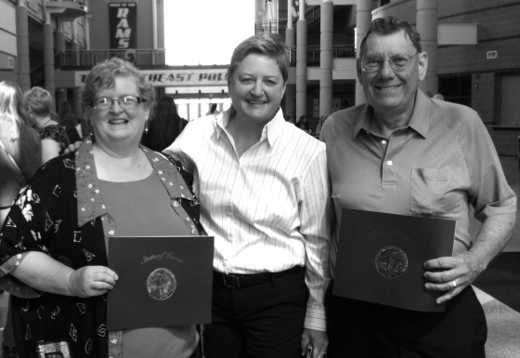
Deb Headington, Fred Lockard, Rob Davis and Mary Ann Nielsen were recognized for their outstanding service to IRIS at the 29th Annual Governor’s Volunteer Awards in Des Moines. Congratulations and thank you!
Pictured: Deb Headington, IRIS director Maryfrances Evans and Fred Lockard.

Notes From Our Listeners
Marie – Sioux City: “My radio is very much appreciated. I use it at night as I awaken often and it is there to listen to politics, pharmaceutical information and the reading of the Sioux City Journal. PS: I will be celebrating my 90th Birthday”
Judy – Iowa City: “My mom used to read the newspaper faithfully, but now that she can’t see the paper, she really depends on IRIS. It’s a wonderful service!”
Mavis – Des Moines: “Thank you for your reading of the Register each morning. I really enjoy listening to the news and staying well-informed.”
Memorial Gifts –
Bequests and memorials are easy ways to ensure that the voices of IRIS can continue for others. If you would like to learn more about how to include IRIS in your final planning, please give us a call at 243-6833.
“Please accept this donation as my way of thanking you folks for the service you’re providing to my mom. She really appreciates having access to local, printed news. It allows her to be more aware of events, deaths and other information. Thank you again, very much!”
Julie J. – Daughter of Des Moines listener

100 East Euclid Ave., Suite 117
Des Moines, Iowa 50313

Free Matter for the Blind
And Physically Handicapped
Iowa Radio Reading Information Service
For the Blind and Print Handicapped, Inc.

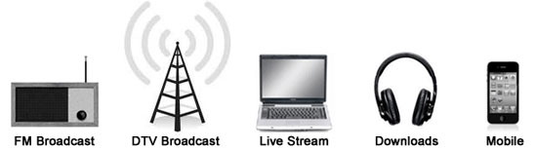
IRIS Delivers ACCESS to Information: On the Air, On your Mobile Device, and On the Web

www.iowaradioreading.org 515-243-6833 1-877-404-4747

Board of Directors:

Mary Ann Nielsen, Chair
Patrick McNulty, Vice-Chair
See Rodari, Treasurer
Catherine Witte, Secretary
Chip Albright
Mollie Cooney
Becky Cox
Julie Gold
Susan Kimelman
Diane Boatwright
Ron Rosenblatt
Laura McVay
Jerry Wickersham
Dr. Jim Feld
Rob Davis
Joe Meisner
Dennis Crabtree
Bonnie Whitson
Staff:
Maryfrances Evans
Jim Boyd
Jeni Rector

