LISTENER:
Application Date |  |  |  |  |  |  |  |  |  |  | Birth Date
First Name |  |  |  |  |  |  |  |  |  |  | Last Name
Address
City/State/Zip
Primary Phone |  |  |  |  |  |  |  |  |  | Email
County |  |  |  |  |  |  |  |  |  |  | Gender |  | Female  Male |  |  | Veteran | Yes  No
Race |  |  |  | Caucasian Black or African American Asian  Hispanic or Latino American Indian or Alaska Native Other
Nature of Disability |  |  |  |  | Legally Blind Physical Difficulty Cognitive Difficulty  Partial Vision Emotional Difficulty Other
Program Schedule Format |  |  |  |  |  |  |  |  |  | Large Print Braille Audio CD mp3 via email
SECONDARY CONTACT:
First Name |  |  |  |  |  |  |  |  |  |  | Last Name
Relationship |  |  |  |  |  |  |  |  |  | Phone |  |  | Email
REFERRAL SOURCE:
First Name |  |  |  |  |  |  |  |  |  |  | Last Name
Ia. Dept. for the Blind Veterans Admin. Friend Presentation Event Family
Organization Name & City _________________________________________________________
Phone |  |  |  |  |  |  |  |  |  |  | Email
EQUIPMENT DETAILS - IRIS USE ONLY: Provided by IRIS Owned by Listener
Radio IPTV Landline Computer Smart Speaker Mobile Device
Radio  Frequency Area |  | Carroll Council Bluffs Cedar Falls Des Moines Dubuque  Ft. Dodge Iowa City Lamoni Mason City Okoboji  Ottumwa Sioux City
Model |  |  |  |  |  |  |  |  | Serial # |  |  |  | IRIS #
Fulfill Date |  |  |  |  |  |  |  | Notes
IowaRadioReading.org Email: IRIS@IowaRadioReading.org 515.243-6833
100 E. Euclid Ave., Ste. 117 Des Moines, Iowa 50313
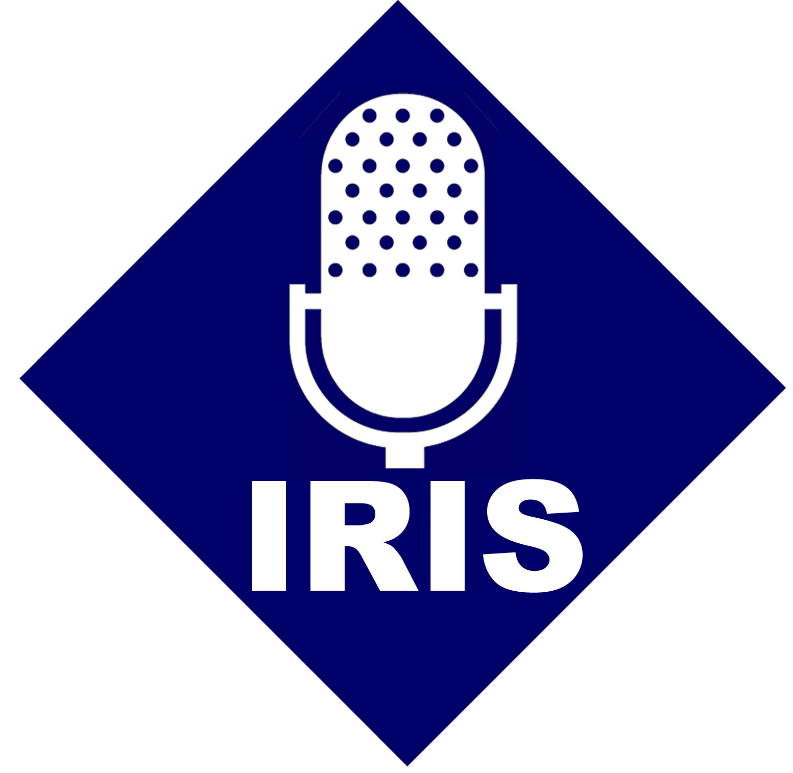
Listener Information
Iowa Radio Reading Information Service for the Blind

